
February 2020
Newsletter

Announcements

Make a difference in your community this tax season. Heard about ReFUNDCO? It’s a new state donation program that allows you to use some or all of your refund to directly support a non-profit of your choice. Look for the DONATE TO A COLORADO NONPROFIT prompt when you file and enter registration #20083005924 to donate to Nederland Area Seniors.

Town of Nederland 2020 Municipal Elections Election Day is Tuesday, April 7, 2020. During this election, residents will be electing a Mayor and five (5) trustees. Are you registered to vote? Nederland residents can register to vote at Town Hall. If you require an absentee ballot, email townclerk@nederlandco.org or mailed to P.O. Box 396, Nederland, CO 80466


Brunch, Saturday, 10am on February 1, 2020 Enjoy a chef-prepared brunch with your neighbors, family and friends at the Nederland Community Center RSVP required. Call 303-258-0799 or email mountainpeaklife.nas@gmail.com

Dinner & Discusssion, Friday, February 21, 2020 Meet your Boulder County Commissioners over dinner, with friends. Join us for an open forum discussion including a dinner of grilled salmon, vegetables, homemade breads, dessert and coffee. RSVP required by February 18. Call 303-258-0799 or Email mountainpeaklife.nas@gmail.com

Volunteers Needed: Our volunteers drive the success of our community programs. If you are interested in volunteering for any of the various programs we host, call us at 303-258-0799
- Activity Leaders: Share your love of winter in Colorado. Suggest or host an event!
- Home-Delivered Meals: Weekly deliveries for homebound older adult mountain residents.
- Mountain Peak Life Meals: Welcome guests at our social dinners and brunches.

Movie Matinees with Open Captions: The Backdoor Theater located in the Nederland Community Center now offers open-captions Saturdays for the 2pm matinee showings. Visit: www.thebackdoortheater.org for current movie titles and times.

Night at the Oscars Fundraiser, Feb. 9 at The Backdoor Theater: Dress Up and Join the BDT for a night at the Oscars. $20/person. Food, beverages and ice cream sundaes will be served.

Foot Care with Nurse Debbie Neal: Serves mountain older adults with toenail/skin care and a review of foot concerns. By appointment in downtown Nederland, $30 fee 303-258-7768

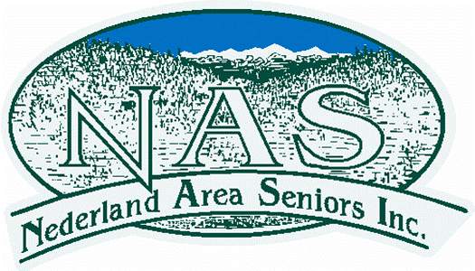
Meal Delivery Program for Home Bound Older Mountain Residents
If you or someone you know is 60 years or older, is unable to attend our weekly congregate meals and would benefit from home delivered nutrition meals, please email mountainpeaklife.nicole@gmail.com or call MPL office: 303-258-0799 for eligibility criteria and scheduling.

Do you Need Medical Equipment? The Holistic Homestead provides mountain residents with FREE medical equipment, including grab-bars, mobility devices and back supports. To request FREE medical equipment call 303-582-3001 or visit: www.theholistichomestead.org

Weekly Calendar
Nederland Community Center (750 HWY 72)
Pickleball: Monday, Wednesday, & Saturday. 10:00am, Community Center fee
Mountain Peak Life Lunch: Monday & Wednesday. Noon. <60: $8.25; >60: $5
Nederland Community Library (200 CO-72)
Writing Skills: FREE. 1st and 3rd Mondays, 1:00pm
Writing Life Stories: FREE. 2nd & 4th Wednesdays, 1:00pm
Quirky Quilters: FREE. First Tuesdays, 10:30am-Noon
St. Rita’s Catholic Church (326 CO -119)
Group Exercise: FREE. Monday & Wednesday, 10:30am

MMenu – November 2019

Nederland Area Seniors & Mountain Peak Life
P O Box 188
Nederland CO 80466

